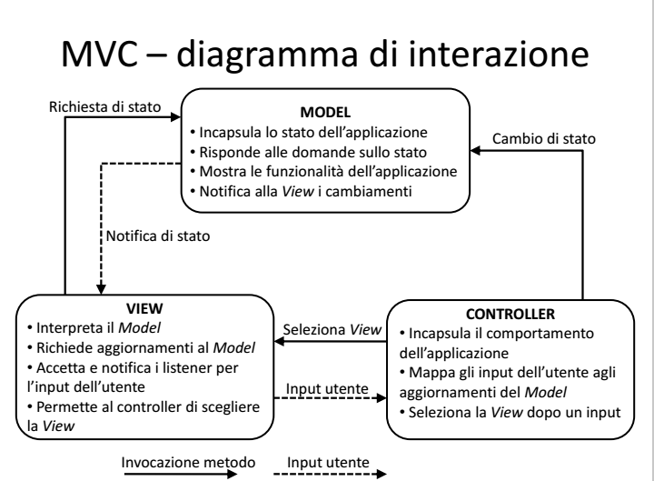
MODEL – CONTROL – VIEW
MODEL : It directly manages the data, logic and rules of the application.
VIEW: the view is simply handling how the data is being displayed to the user.(reusable)
CONTROLLER: The controller receives the input, optionally validates it and then passes the input to the model is the glue between the two. It should never have any of the actual game logic in it.

https://en.wikipedia.org/wiki/Model%E2%80%93view%E2%80%93controller
https://stackoverflow.com/questions/555283/how-can-you-organize-the-code-for-a-game-to-fit-the-mvc-pattern
https://www.javacodegeeks.com/2012/02/building-games-using-mvc-pattern.html

You got it the wrong way around. One of the points of MVC is to make the model independent of the view. I.e the model shouldn't know about the view (or rather it shouldn't need to care). The view on the other hand needs to use model objects to do its thing. I've never designed a non-web application with MVC in mind. The view is normally a JSP/HTML/XHTML/XML file, its role is about making the program look in a certain way. So everything regarding rendering, placement, etc. fits into the view. The controllers job is to collect data from the model and pass it along to the view in a form that the view can use in a simple way, and also handle things like navigation between views. It's the glue that keeps the view and model together. Thus:
The model depends on nothing. The controller depends on the model. The view depends on the controller and model.
https://en.wikipedia.org/wiki/Singleton_pattern#Java

A Visual Guide to Layout Managers

Basics
http://forum.codecall.net/topic/71962-c-collapse-game/
https://www.youtube.com/watch?v=sJsMGR_xvqM --> spongebob
https://www.dreamincode.net/forums/topic/237851-detecting-adjacent-cells-in-2d-array/

Docs

https://stackoverflow.com/questions/21898425/how-to-use-cardlayout-with-netbeans-gui-builder
https://docs.oracle.com/javase/7/docs/api/java/awt/MediaTracker.html
https://docs.oracle.com/javase/7/docs/api/java/lang/reflect/Field.html
layeredpanel per sovrapporre componeneti

Altri
https://stackoverflow.com/questions/10797663/removing-range-tail-from-a-list
https://stackoverflow.com/questions/20327958/random-number-with-probabilities
https://stackoverflow.com/questions/5822384/getting-a-color-from-a-string-input /
http://www.simplesoft.it/background_image_per_componenti_java_swing.html
https://stackoverflow.com/questions/7876186/proportional-resizing-of-jframe (pack())
https://www.dreamincode.net/forums/topic/326837-add-a-button-on-top-of-background-image/
new ArrayList<>(Arrays.asList(array)).subList()
List lst = Arrays.asList(this.boardArray[0]);
https://stackoverflow.com/questions/1073919/how-to-convert-int-into-listinteger-in-java
int[] into List<Integer>
List<Integer> intList = new ArrayList<Integer>();
for (int i : ints)
{
intList.add(i);
}

EachWordUpperCaseClass, firstWordLowerCaseMethod(), firstWordLowerCaseAttribute unless it is an UPPER_CASE_CONSTANT
https://stackoverflow.com/questions/24956245/aligning-jpanels-in-jpanel
Debug and breackpoint
https://www.youtube.com/watch?v=9DBQyLXXvYI

https://stackoverflow.com/questions/24338073/imageobserver-not-working

Suono& effetti

Volume suono:
volume: - 00001111 +
https://stackoverflow.com/questions/953598/audio-volume-control-increase-or-decrease-in-java

https://docs.oracle.com/javase/tutorial/uiswing/components/slider.html

https://docs.oracle.com/javase/tutorial/uiswing/examples/components/SliderDemoProject/src/components/SliderDemo.java
Volume effetti
BUBBLE EFFECT : http://zetcode.com/gfx/java2d/effects/

style blocchi
effetti blocchi (label) effetti blocchi speciali (label) effetti menù (label)
punteggi su schermo (label) (visivo+suono)

- Image newImage = yourImage.getScaledInstance(newWidth, newHeight, Image.SCALE_DEFAULT);
- +drawImage in extend JPanel class

- ComponentListener to resize an image (check boardpanel)

- ImageBlaster: https://stackoverflow.com/questions/17854661/how-to-display-an-images-instantly-in-java-applet
Swing based components, the MediaTracker is redundant. A JPanel is anImageObserver
MediaTracker guarantees that an image is loaded at a given point

- private final static Dimension PREFERRED_SIZE = new Dimension(NUM_COLUMNS * CELL_SIZE, CELL_SIZE +15);
https://stackoverflow.com/questions/4801386/how-do-i-add-an-image-to-a-jbutton

Sprites
https://stackoverflow.com/questions/35472233/load-a-sprites-image-in-java

BufferedImage image = ImageIO.read(new File(...PATH...));
Graphics g = panel.getGraphics();
g.drawImage(image, x, y, imageObserver (most likely null));

sprites[(i * columns) + j] = ss.getSubimage(i * width, j * height, width, height);

http://studentguru.gr/b/dt008/archive/2015/02/25/building-a-match-3-game-like-candy-crush-in-unity

Scores

http://forum.codecall.net/topic/50071-making-a-simple-high-score-system/
punteggi proporzionali (numero blocchi rimossi)

https://stackoverflow.com/questions/3879610/how-to-clear-contents-of-a-jtable
https://stackoverflow.com/questions/28128035/how-to-add-table-header-and-scrollbar-in-jtable-java

jknight tour model - getNeighbour per navigatore pezzi - boolean visited
metodi privati paintBoard(), paintPath(), paintKnight() paintHighlight() paintLoader(), <- Con particolare attenzione la divisione dei paint componenti separando quella del loader per non avere interruzioni
ciascuno dei quali si occupa di disegnare una parte specifica della scacchiera

Timer
this.timer = new Timer(Config.getInstance().getDelayTime(), this);
https://docs.oracle.com/javase/tutorial/uiswing/misc/timer.html
timer in mainGuI
IncrementPanel extends JPanel implements ActionListener
public void ActionPerformed()

SOLUTION:
https://stackoverflow.com/questions/33926848/how-to-make-tetris-blocks-fall-down-every-second-error

Controller: manageClickOnBoard()
updateView()

TO DO
space to able/disable keyboard input (+highlight)
catch exeptions: color not found, sprite not found, background not found-> launch exeption : message immagini non presenti

Config: [Textures] Skin = sea, rock, normal

private Block[][] boardAr; in model

https://stackoverflow.com/questions/523767/how-to-set-background-image-in-java
sprites+background
https://stackoverflow.com/questions/10634417/image-resize-to-fit-on-jpanel

Change player on score board
Set new instance when open score 0 game

REMOVE MODEL FROM VIEW → controller
CHANGE INCLIN → BLOCK LOADER
IF COULD NOT FIND SPRITES LOAD PAINT

Metodologia per rimuovere I blocchi (set visited → remove → trim() )
Si è scelto MCV per la possibilità di riutilizzare blocchi di view grazie al distaccamento con il Model
(sprites, sound, grafica visiva)

https://stackoverflow.com/questions/5599210/saving-properties-in-a-file-with-java-formatted
https://stackoverflow.com/questions/40514910/set-volume-of-java-clip

